- Find the total Revenue , quantities and profit generated.
Solution: select sum(sales) as total_ revenue,
sum(quantity)as quantities, sum(profit)as profit from superstore;
o/p -
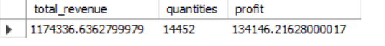
- Find the Segment wise distribution of the sales.
Solution:
select segment, sum(sales) as distribution_ of_ sales
from superstore
group by segment;

o/p-
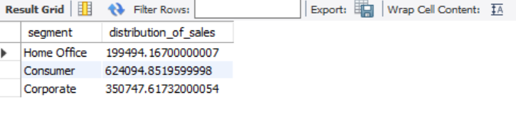

- Find the top 3 profitable product.
Solution:
SELECT
`Product Name`,
SUM(Profit) AS Total_ Profit
FROM superstore
GROUP BY `Product Name`
ORDER BY Total_ Profit DESC
LIMIT 3;

O/P:

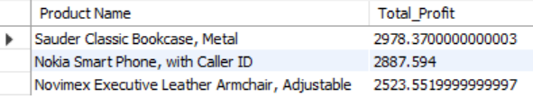

- Find how many orders are placed after January 2016.
Solution:
SELECT
COUNT (DISTINCT `Order ID`) AS Orders_After_Jan2016
FROM superstore
WHERE 'Order Date' > '2016-01-31';

O/P:


- How many states from Mexico are under the roof of business?
Solution:
SELECT
COUNT (DISTINCT State) AS States_ in_ Mexico
FROM superstore
WHERE Country = 'Mexico';

O/P-
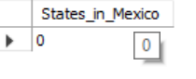
- Which products and subcategories are most and least profitable?
SOLUTION:
SELECT `sub-category`, `Product Name`, SUM(Profit) AS Total_ Profit
FROM superstore
GROUP BY `sub-Category`, `Product name`
ORDER BY total_ Profit DESC
LIMIT 1;
O/P-

-- Least profitable
SELECT `Sub-Category`, `Product Name`, SUM(Profit) AS Total_ Profit
FROM superstore
GROUP BY `sub-Category`, `Product Name`
ORDER BY total_ Profit ASC
LIMIT 1;

O/P-
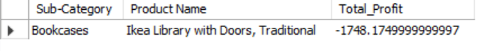
- Which customer segment contributes the most to the total revenue.
SOLUTION:
SELECT
Segment,
SUM(Sales) AS Total_ Revenue
FROM superstore
GROUP BY Segment
ORDER BY Total_ Revenue DESC
LIMIT 1;

O/P-
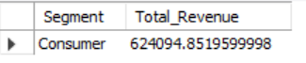

- What is the year-over-year growth in sales and profit.
SOLUTION:
SELECT
t1.Year,
t1.Total_Sales,
t1.Total_Profit,
ROUND(((t1.Total_Sales - t2.Total_Sales) / t2.Total_Sales) * 100, 2) AS YoY_Sales_Growth_Percent,
ROUND (((t1. Total _Profit - t2.Total_Profit) / t2.Total_Profit) * 100, 2) AS YoY_ Profit_ Growth_ Percent
FROM (
SELECT YEAR (`Order Date`) AS Year, SUM(Sales) AS Total_ Sales, SUM(Profit) AS Total_ Profit
FROM superstore
GROUP BY YEAR (`Order Date`)
) t1
LEFT JOIN (
SELECT YEAR(`Order Date`) AS Year, SUM(Sales) AS Total_ Sales, SUM(Profit) AS Total_ Profit
FROM superstore
GROUP BY YEAR(`Order Date`)
) t2 ON t1.Year = t2.Year + 1
ORDER BY t1.Year;

O/P:
- Which countries and cities are driving the highest sales?
SOLUTION:
select country, city, sum(sales)as total_ Sales
from superstore
group by country, city
order by total_ sales DESC
LIMIT 10;

O/P:
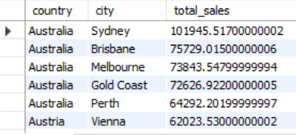

- What is the average delivery time from order to ship date across regions?
SOLUTION:
SELECT
Region,
ROUND(AVG(DATEDIFF(
STR_TO_DATE(`Ship Date`, '%Y-%m-%d'),
STR_TO_DATE (`Order Date`, '%Y-%m-%d')
)), 2) AS Avg_ Delivery_ Days
FROM superstore
WHERE `Ship Date` IS NOT NULL
AND `Order Date `IS NOT NULL
GROUP BY Region
ORDER BY Avg_ Delivery_ Days;

O/P:
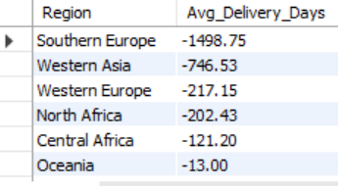
- What is the profit distribution across order priority?
SOLUTION:

SELECT
`Order Priority`,
SUM(Profit) AS Total_ Profit,
COUNT (`Order ID`) AS Total_ Orders
FROM superstore
GROUP BY `Order Priority`
ORDER BY Total_ Profit DESC;

O/P:
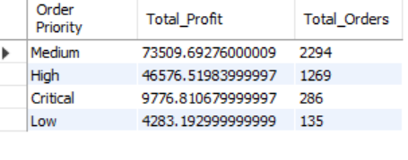
- Suggest data-driven recommendations for improving profit and reducing losses.
SOLUTION:
- Focus on high-profit subcategories and regions.
- Reduce discounts on low-margin products.
- Optimize shipping times and inventory for better efficiency.

